**BIT302**

**Software Engineering**



**ASSIGNMENT 2**

**Design & Test Document**

**“Web-based Information System for MicroHousing System in Kuala Lumpur”**

**Team Leader:**

**Luh Wulandari Maharani**

**E1700873 / 170030401**

**luhwulandari@gmail.com**

**Member:**

**Rivaldo Bagus Soepardhy**

**E1700882 / 170030400**

**aldobagus@hotmail.co.id**

Table of Content

Introduction 1

Use Case Diagram 2

Architectural Design 3

Class Diagram Design 4

Entity Relationship Diagram (ERD) 5

Sitemap 6

Wireframe (General UI Design) 7

System Sequence Diagram + Contracts 8

Database Design 21

Iteration 1 22

Use Case 22

Test Objectives 23

Test Plan 24

Unit Testing 24

Integration Testing 25

System Testing 25

Test Analysis Report 26

Updated Gantt Chart, Trello Board, GitHub 27

Introduction

Every software development must have a clear and understandable requirement or specification to ensure developers can keep developing software within the boundary of requirement, while also, developer can adjust to what users need with the software, and developers can optimize the software according to users’ need.

Previously, we already created the general requirement of what kind tools and how our web-based information system will be developed. In this document, we will give you the design specification and other deliverables regarding to the project, such as SSD, ERD, Database Design, Wireframe, etc.

Use Case Diagram

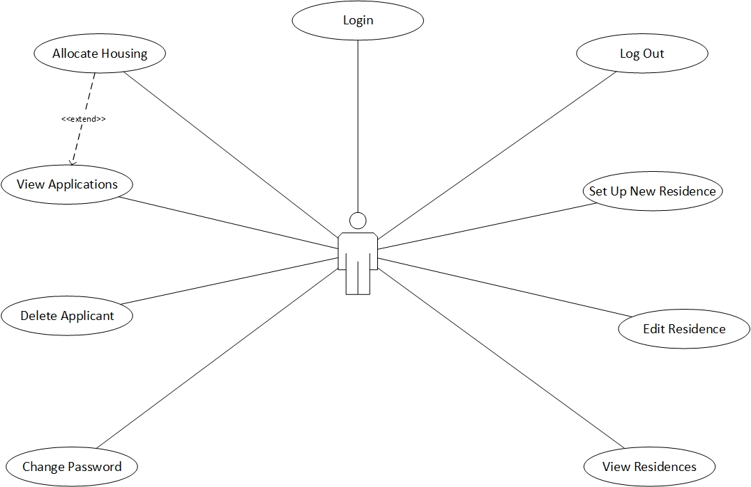

*Use Case Diagram with Actor HousingOfficer*

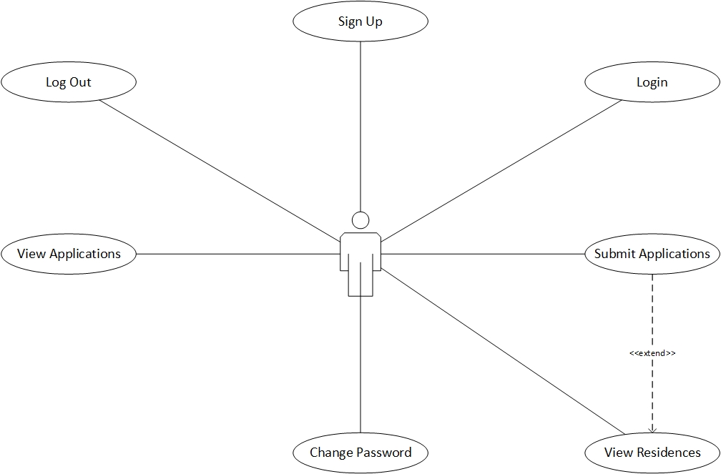

*Use Case Diagram with Actor Applicant*

Architectural Design

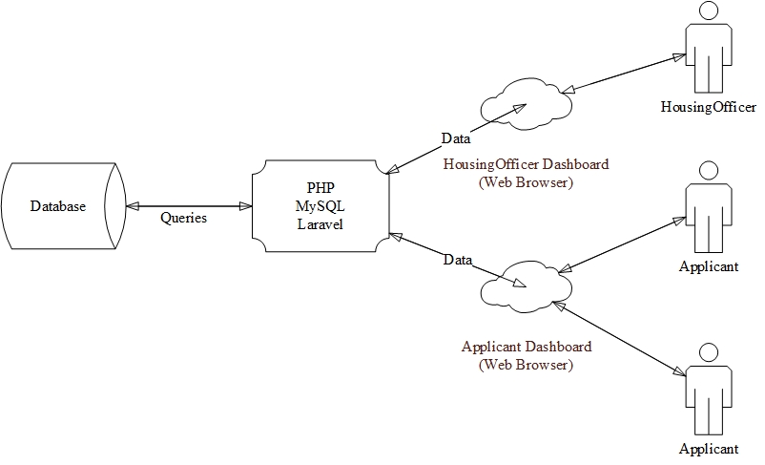

Class Diagram Design

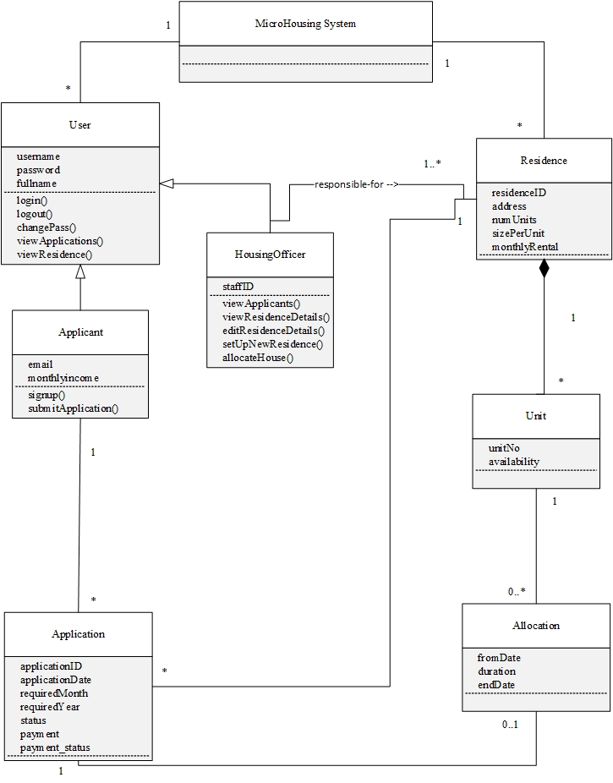

Entity Relationship Diagram (ERD)

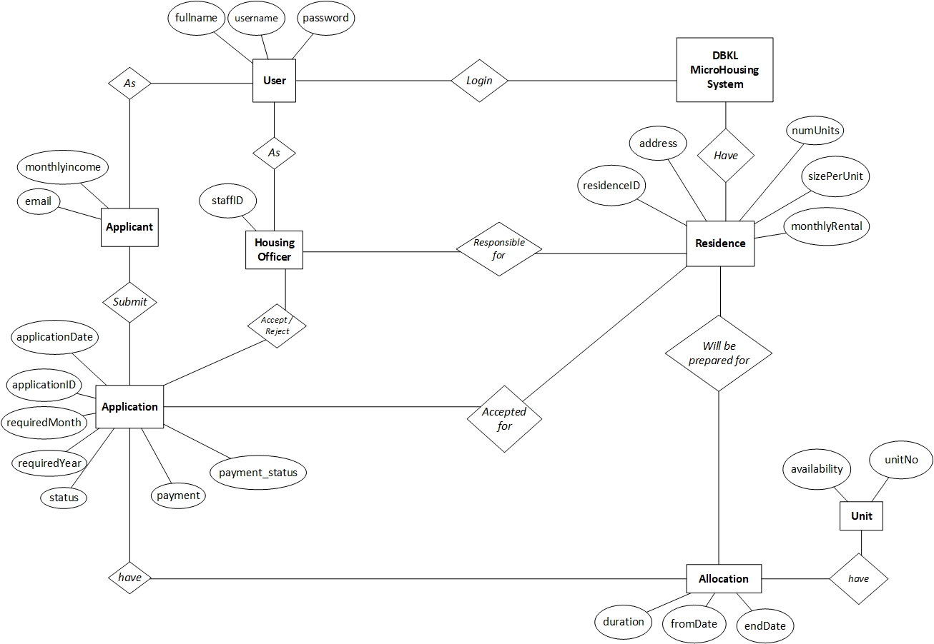

Sitemap

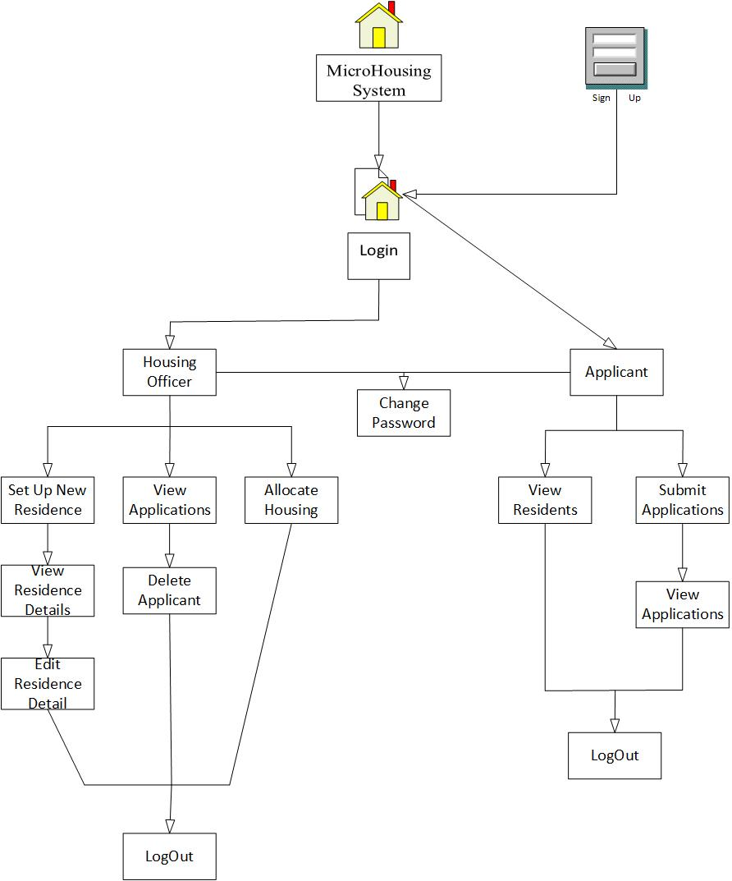

Wireframe

Housing Officer

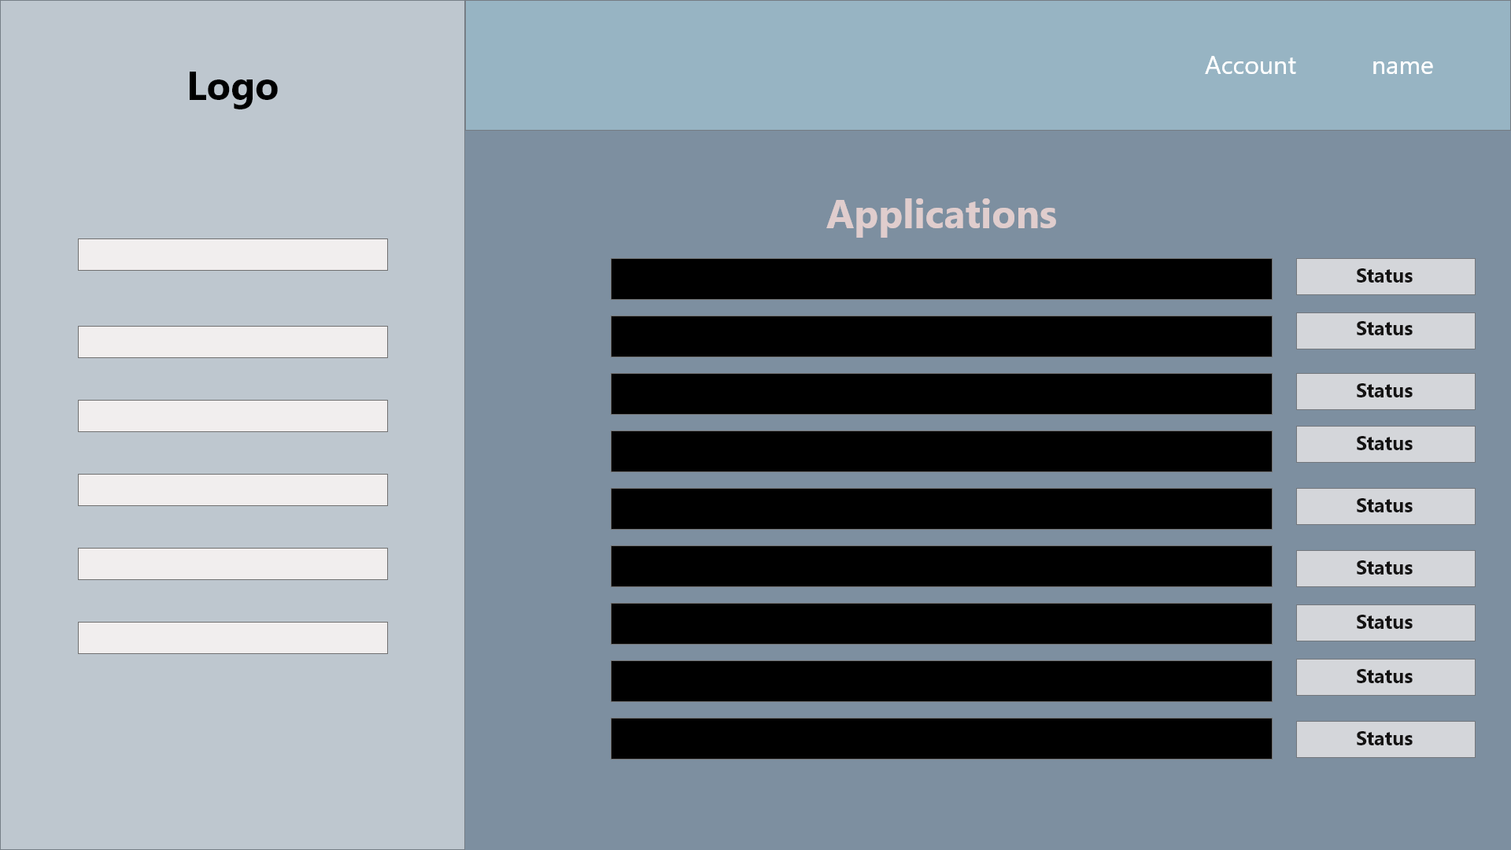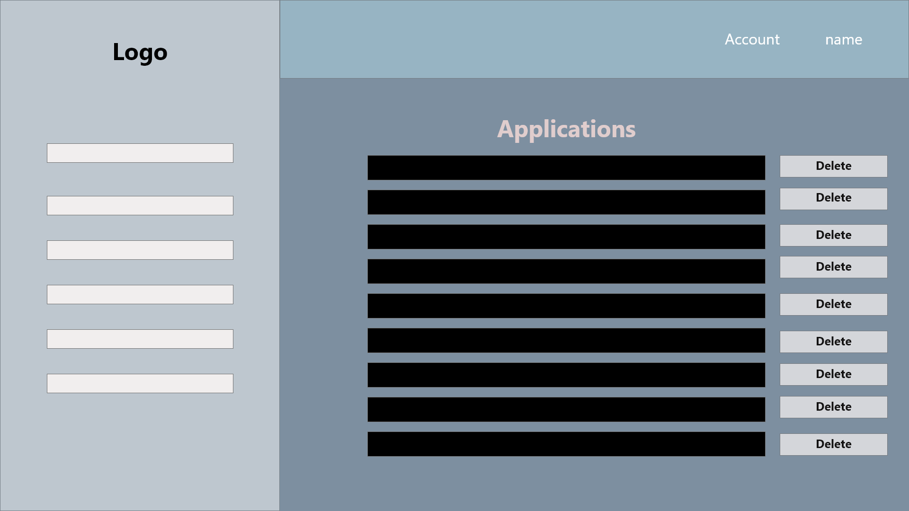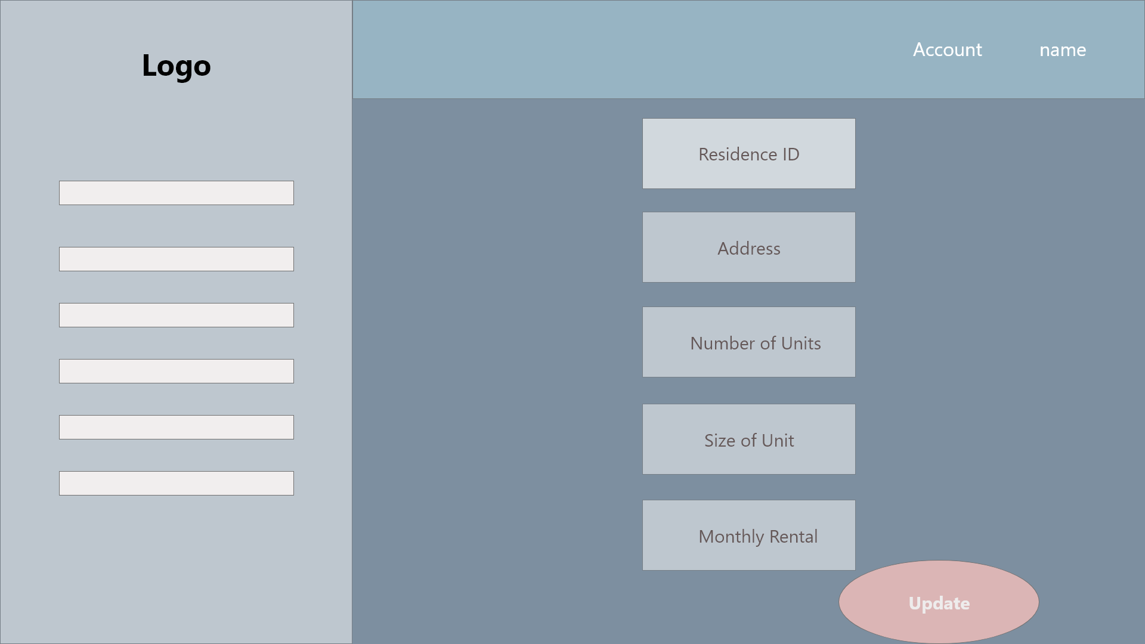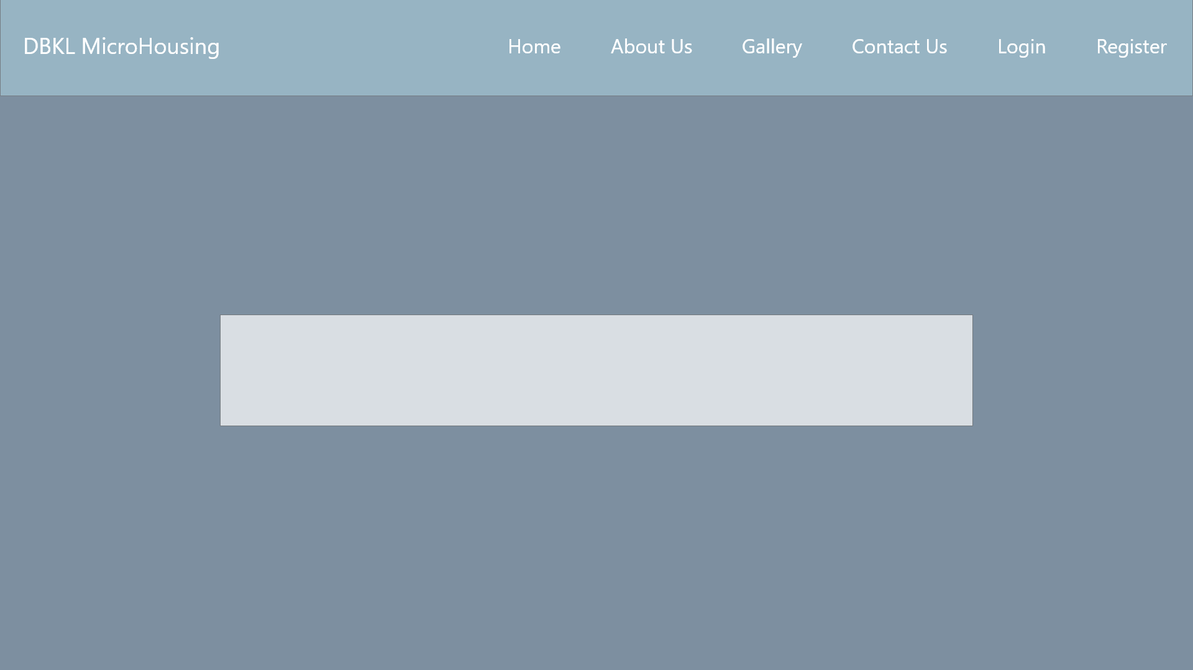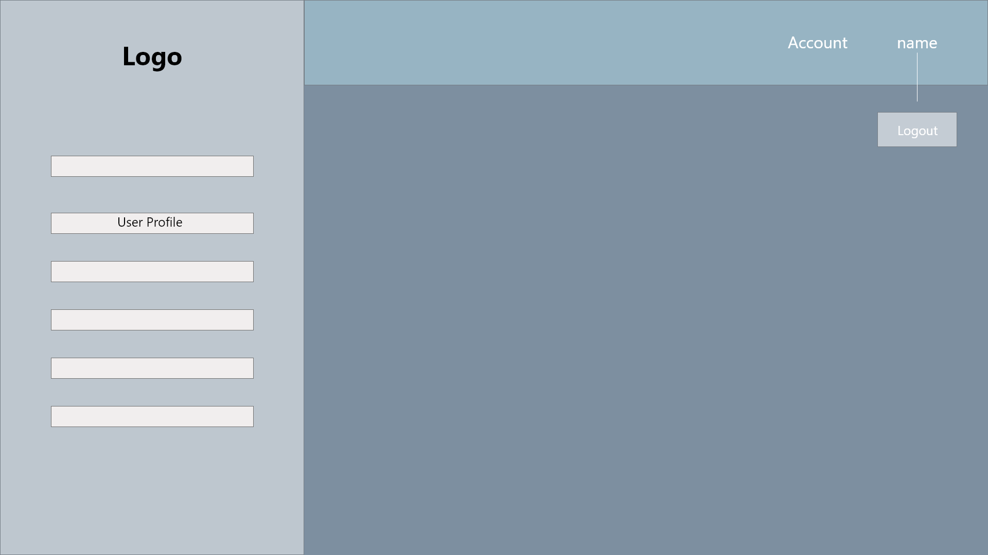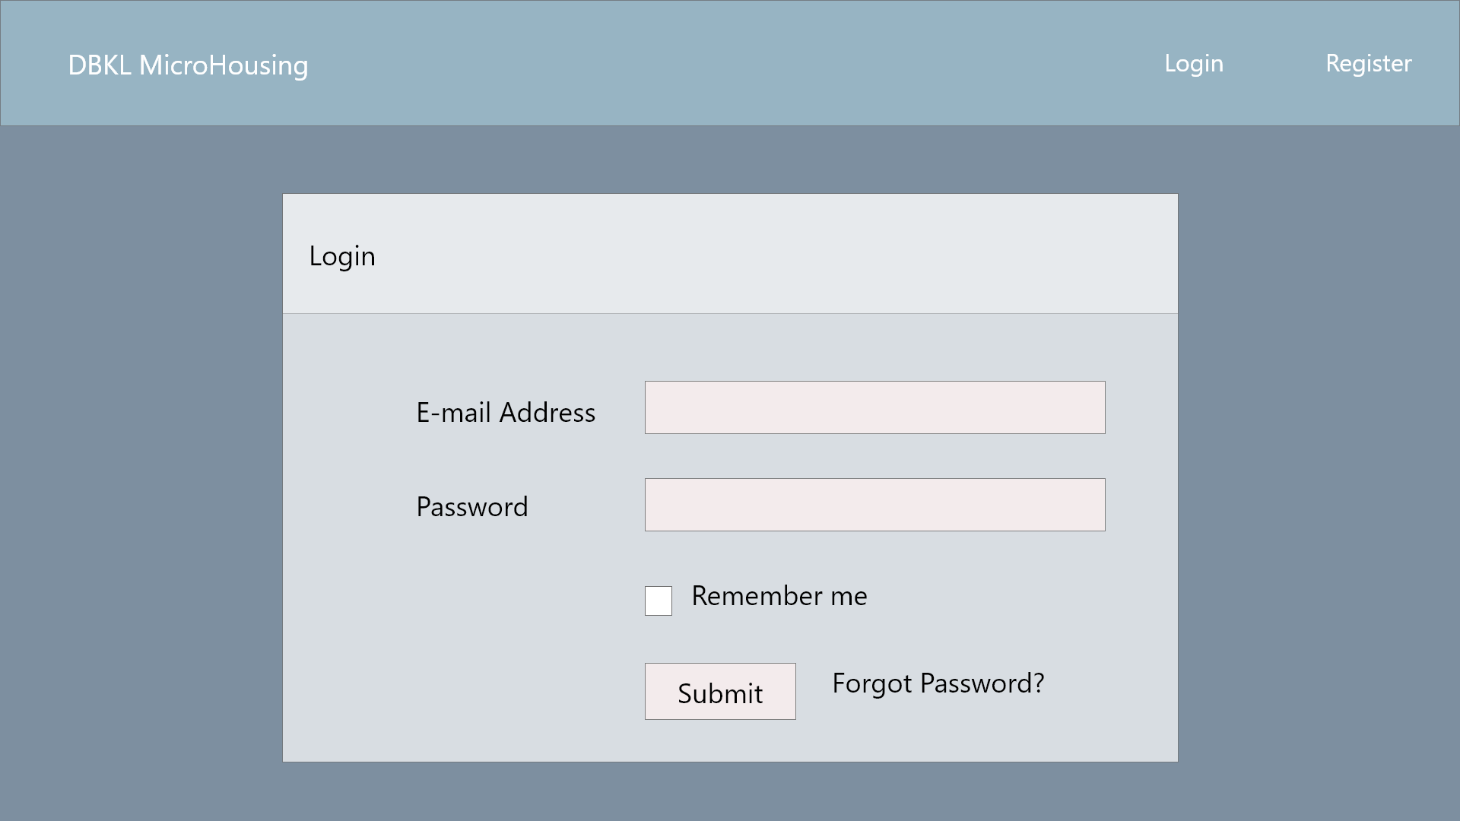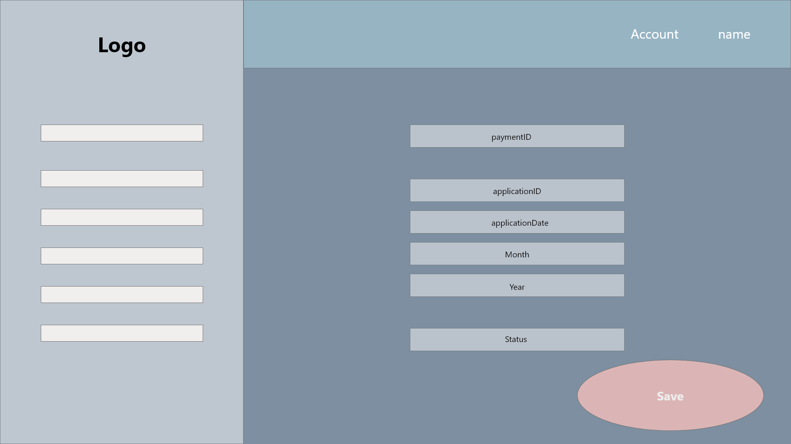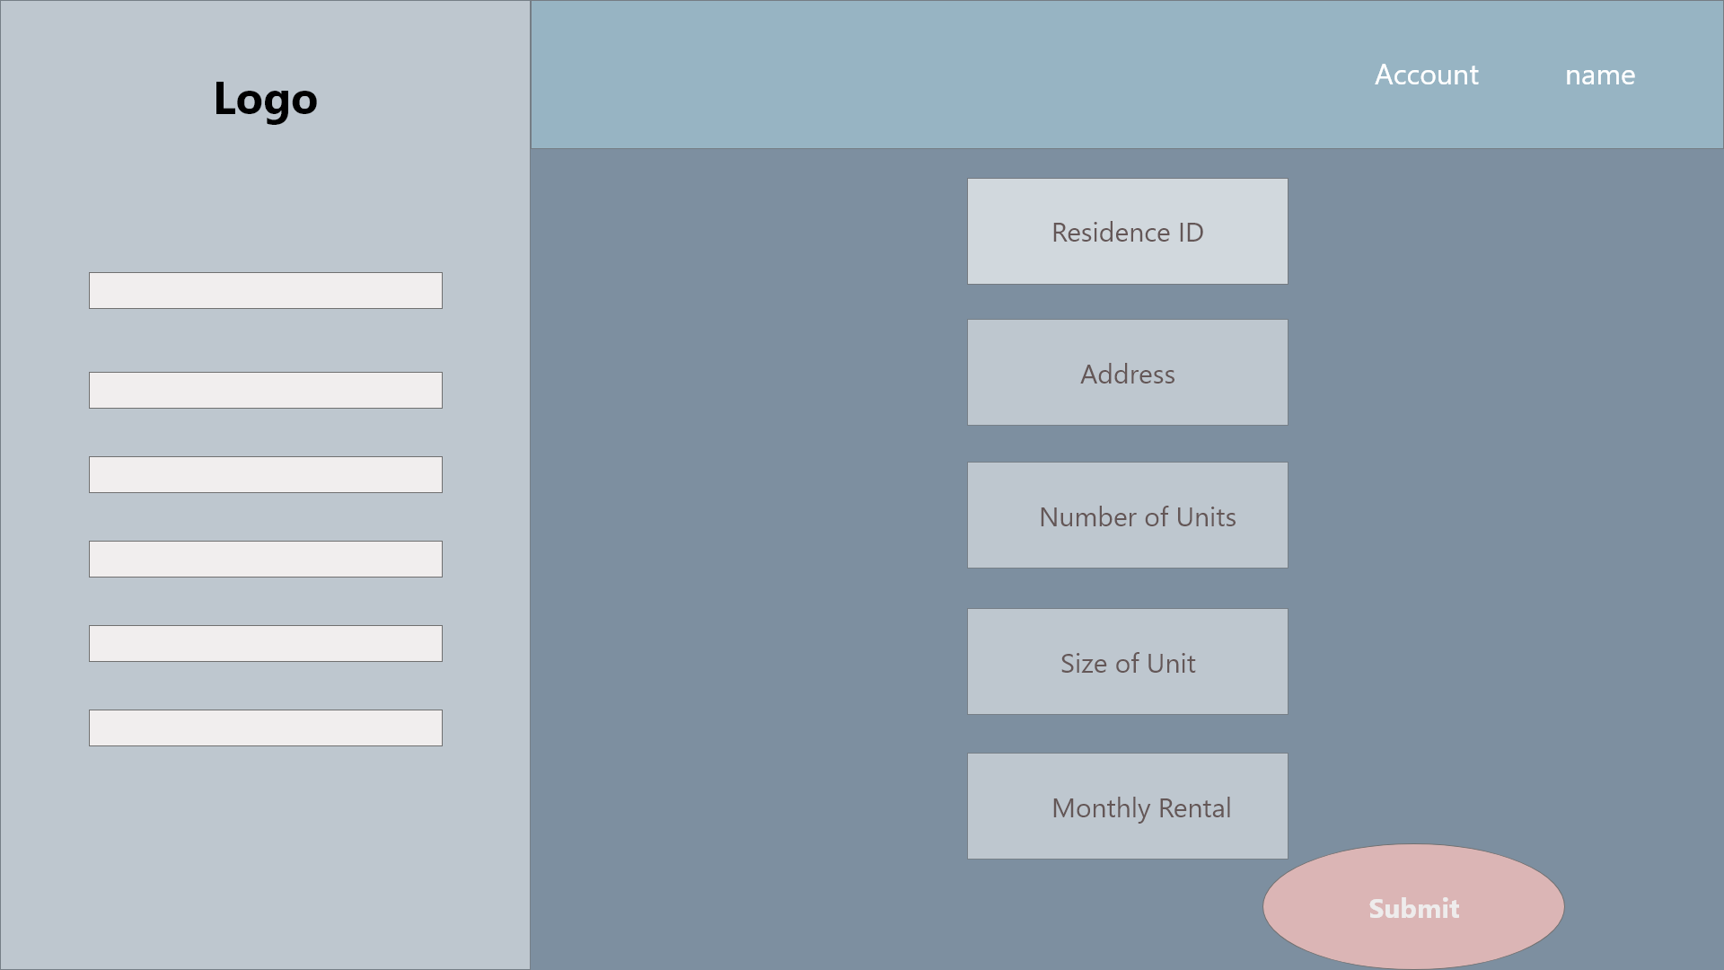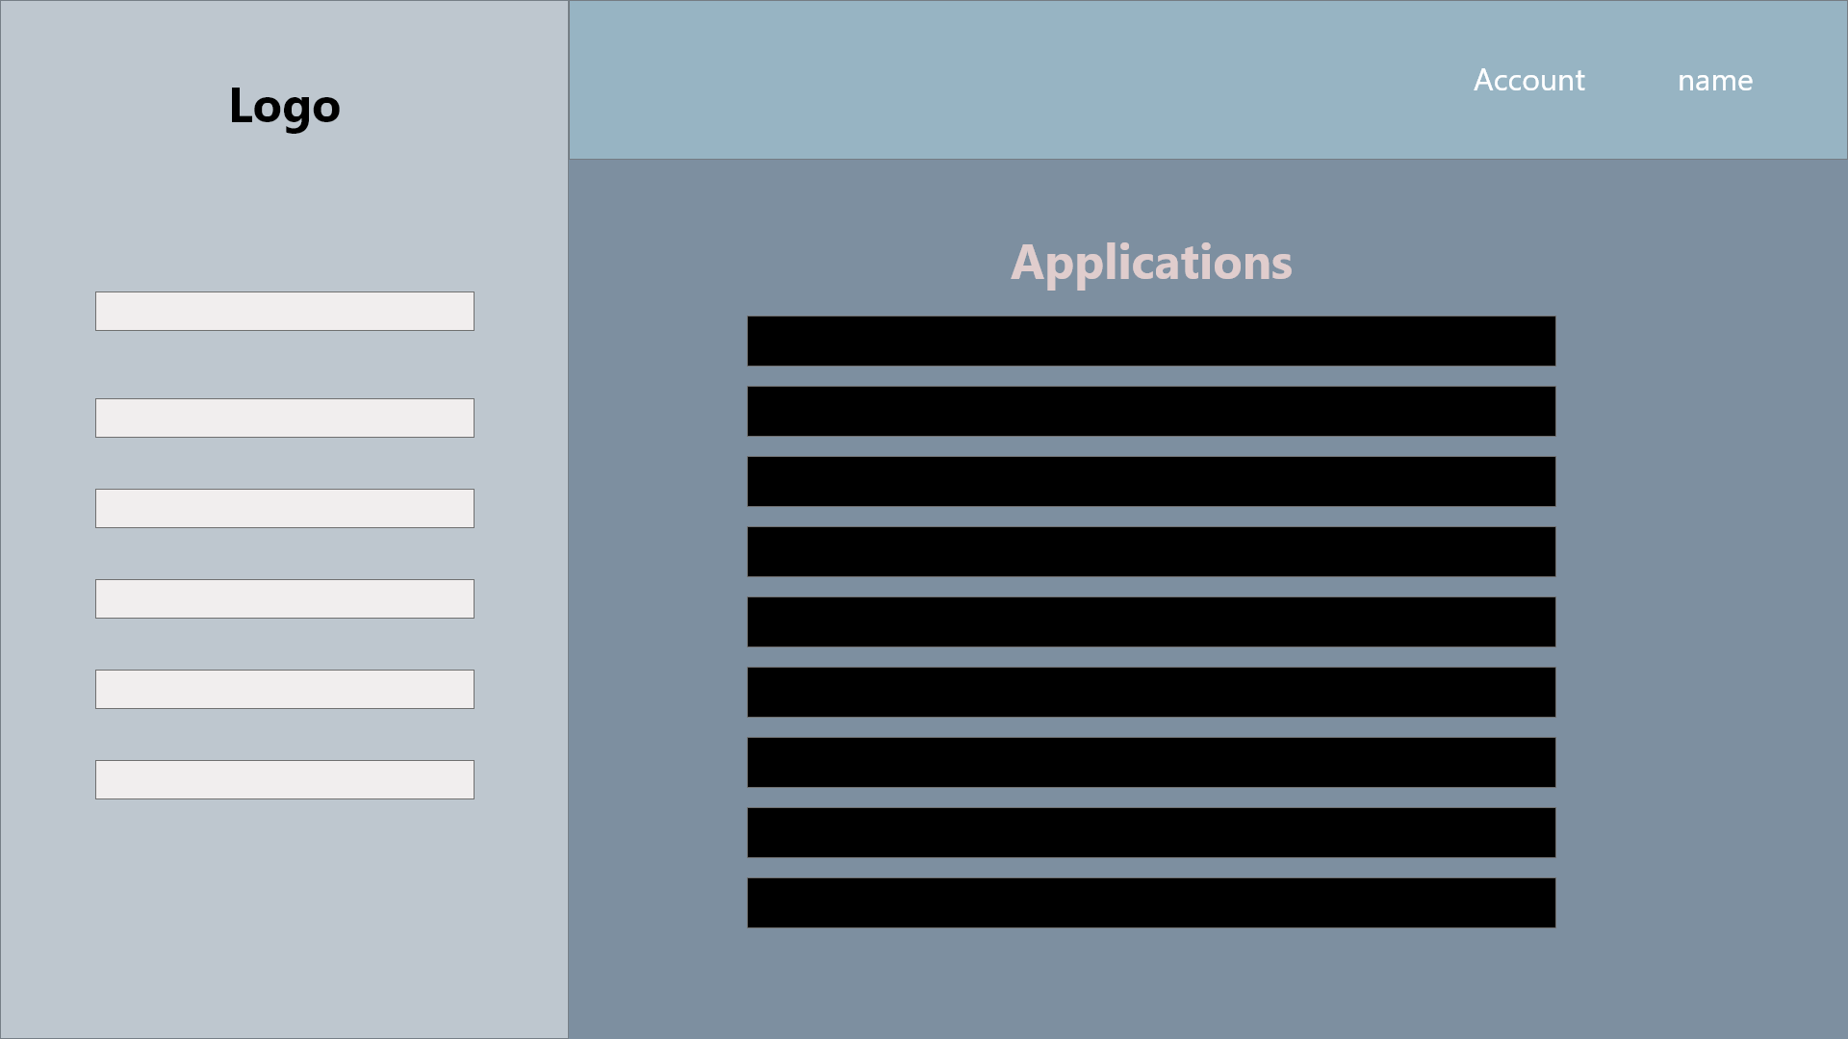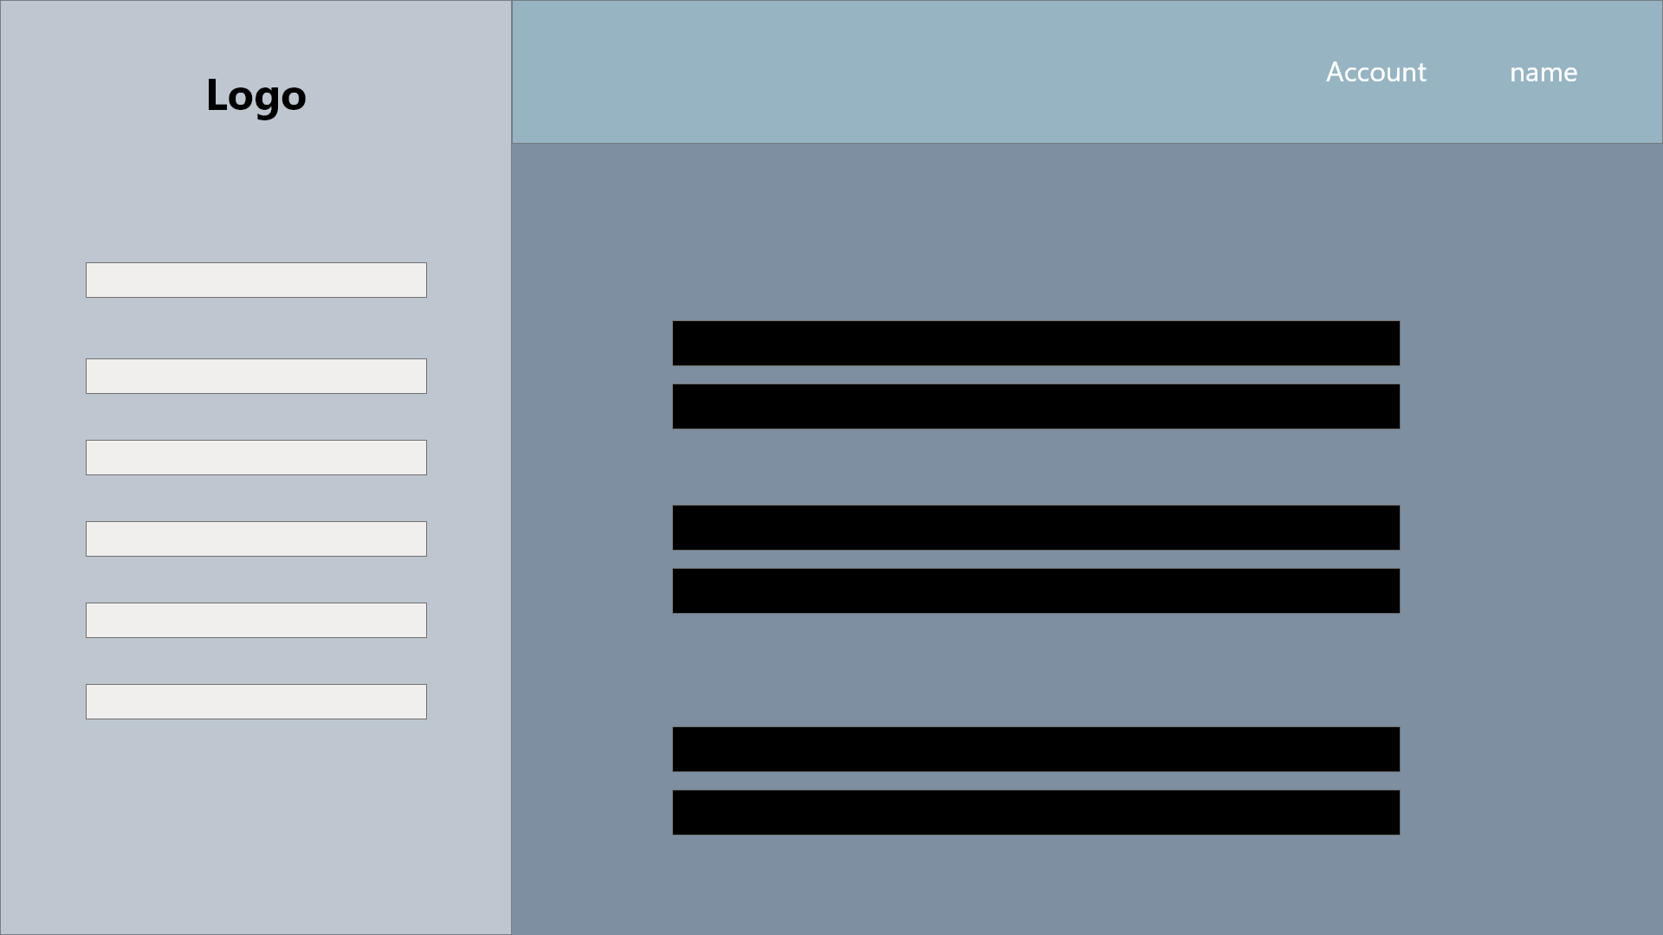

Applicant

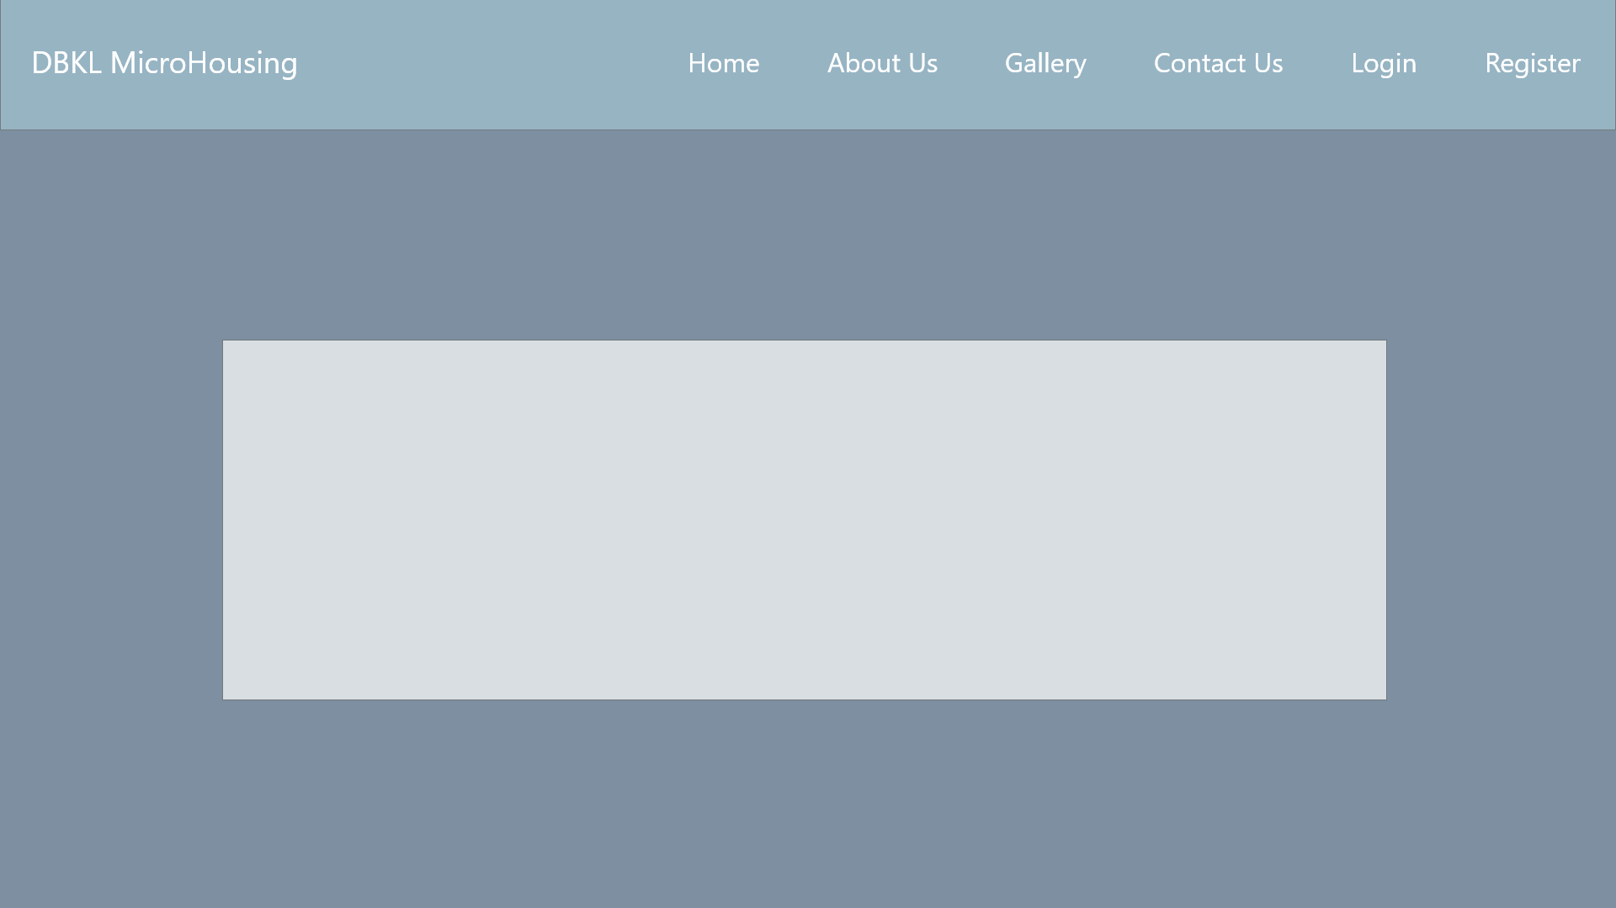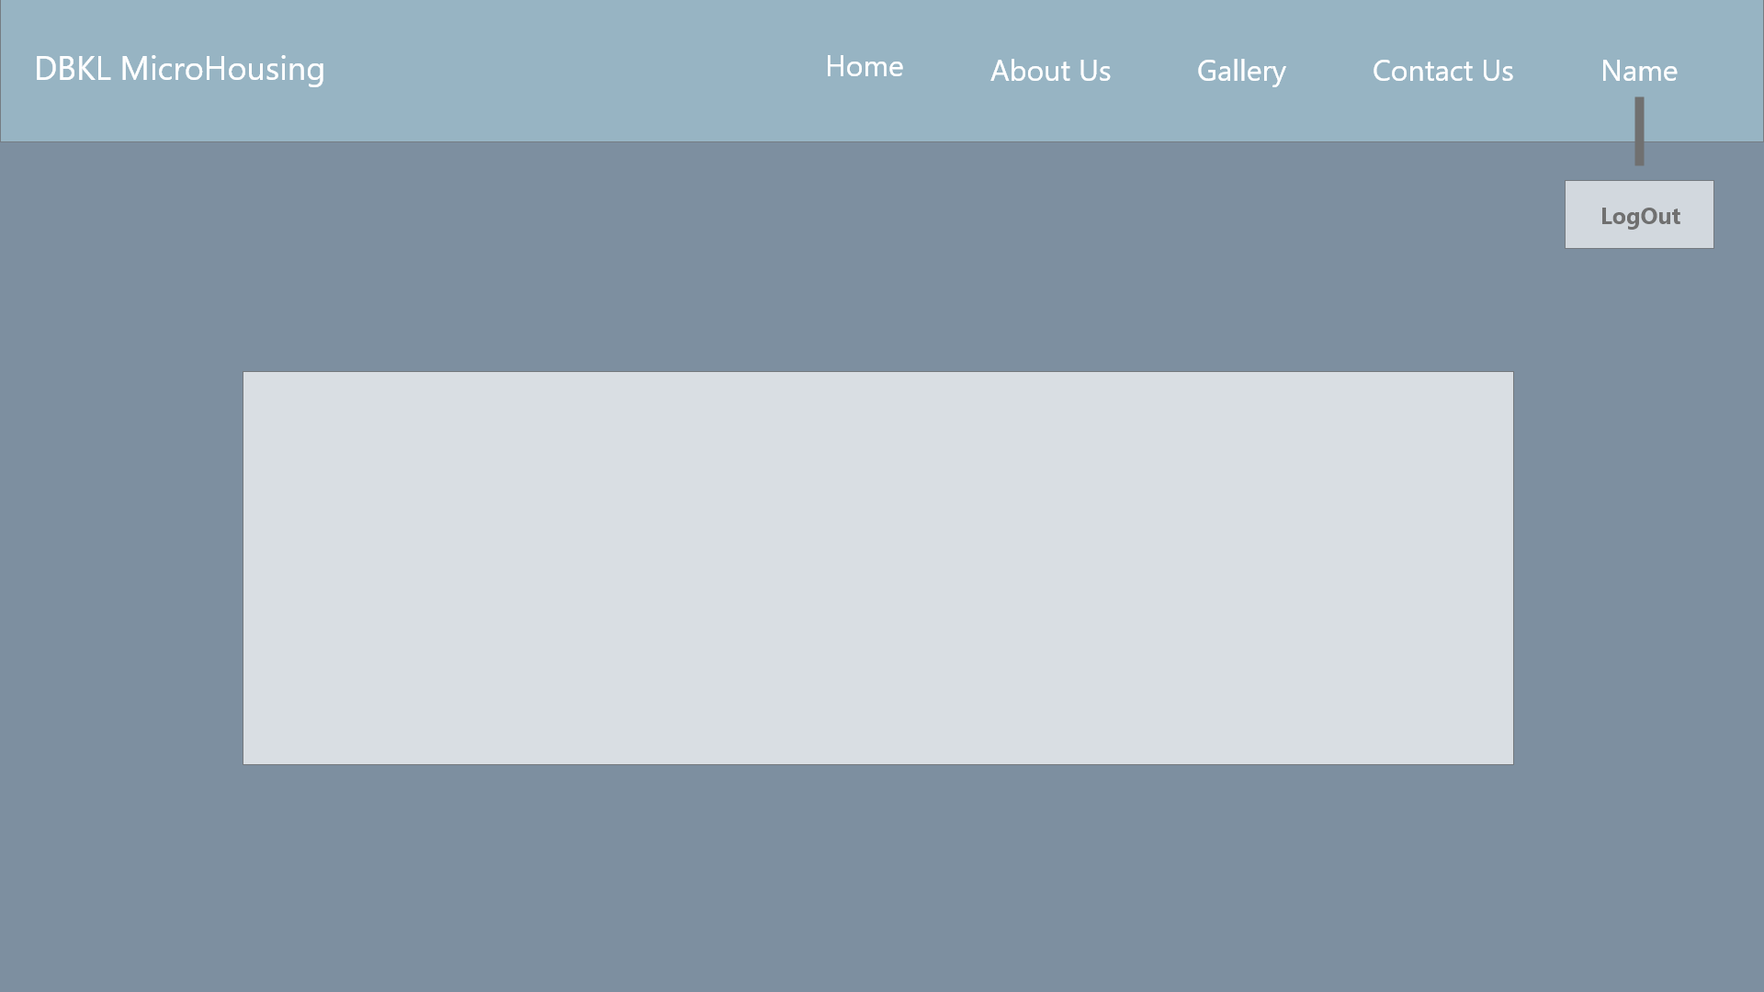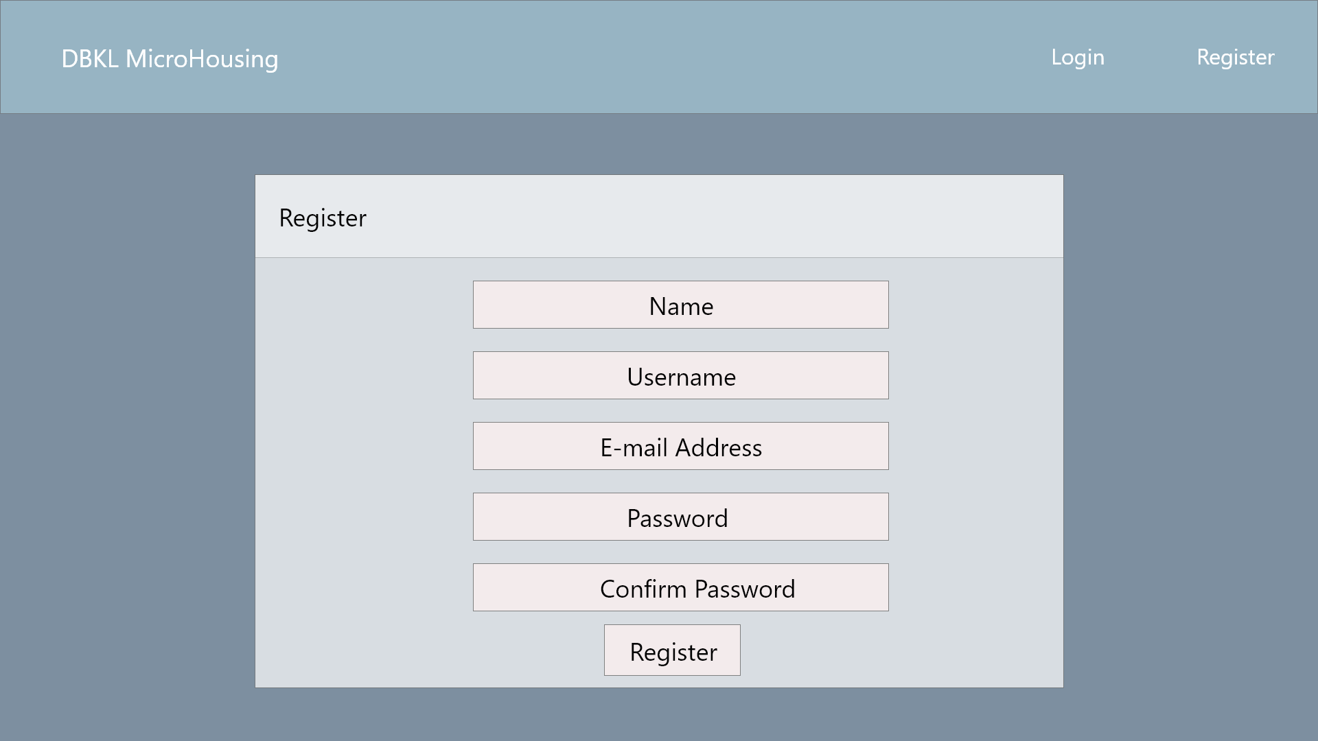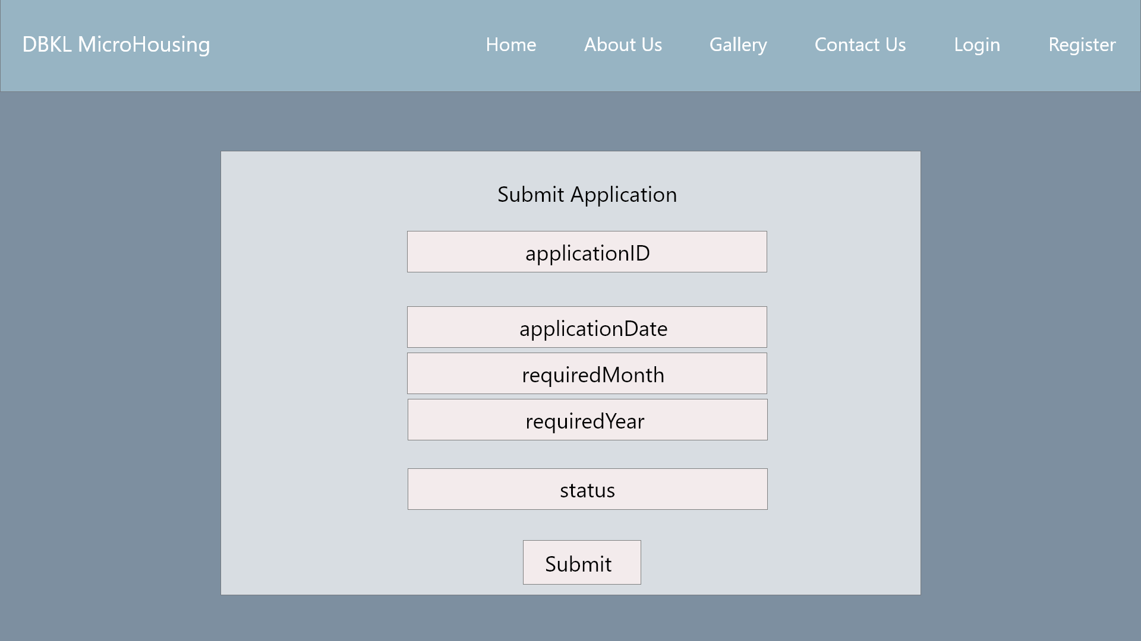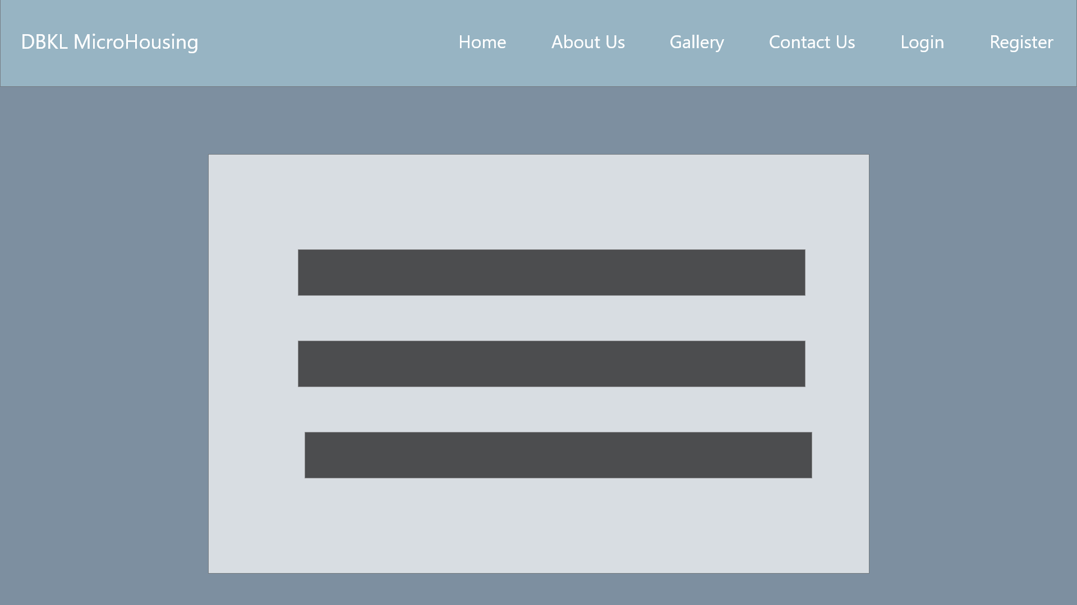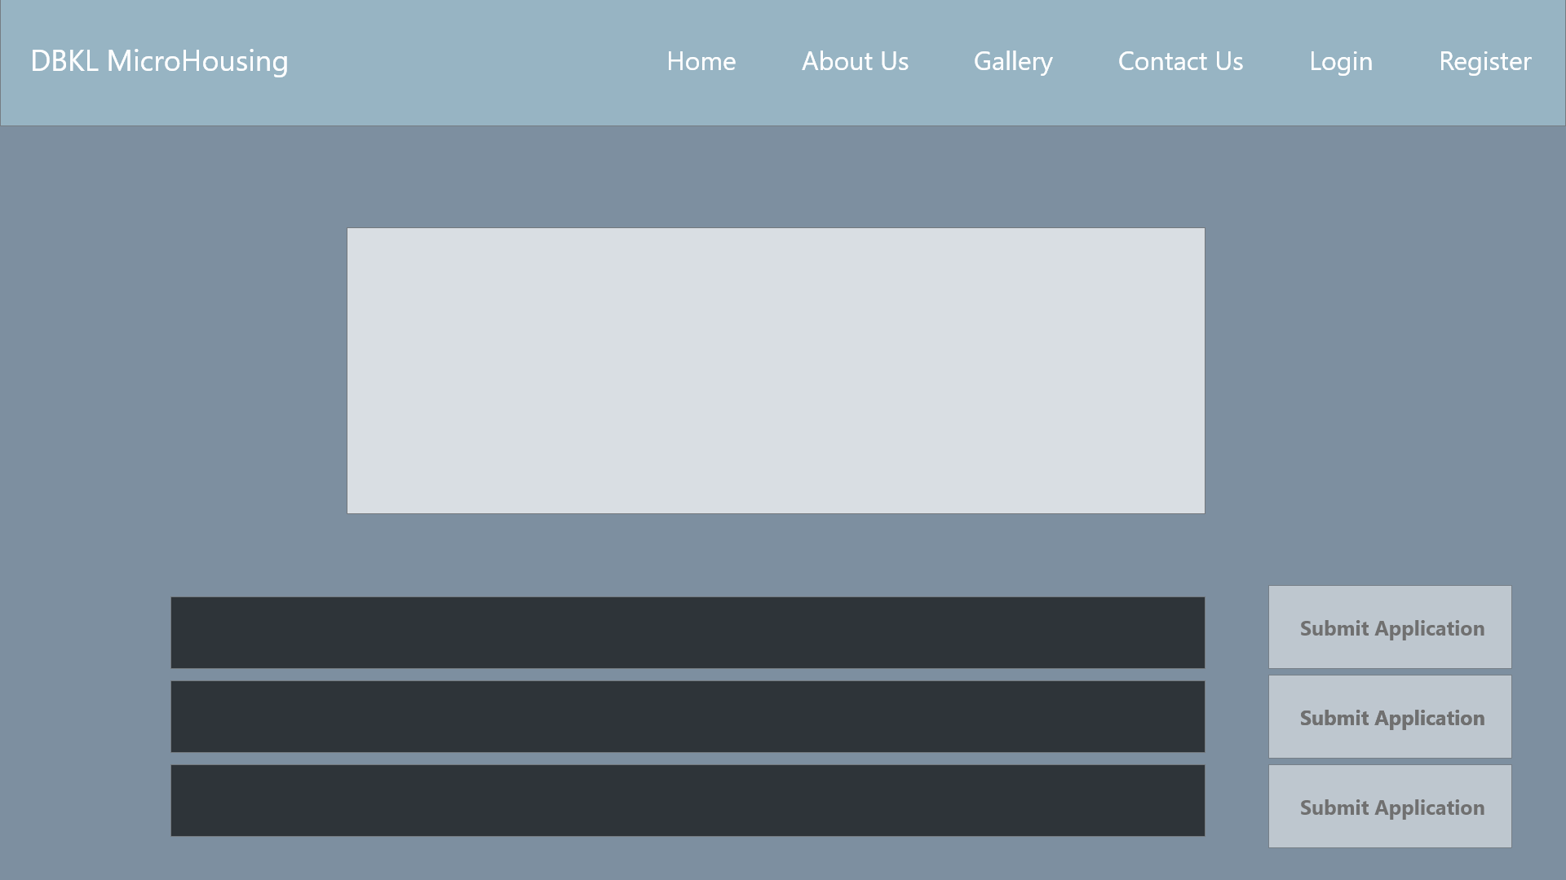

System Sequence Diagram + Contracts

1. **Login**

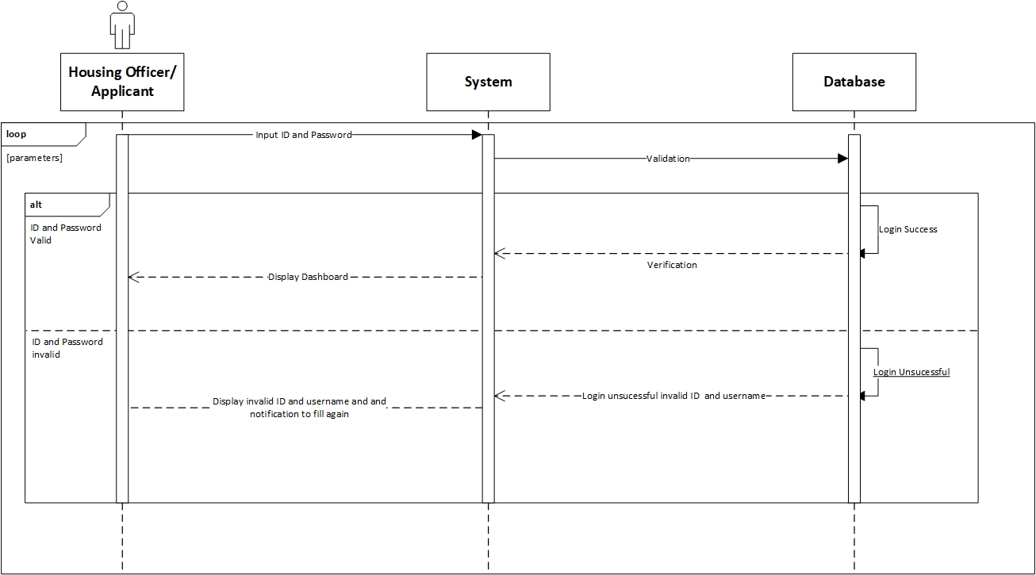

**Prepared by: Luh Wulandari Maharani**

|  |  |
| --- | --- |
| **Cross References** | **Login** |
| Operation | Login with ID and username |
| Responsible | To access the main page |
| Pre-conditions | * Username must be available * Password must be available |
| Post-conditions | * Username is matched * Password must be match based on user’s password input * Display dashboard |

1. **Change Password**

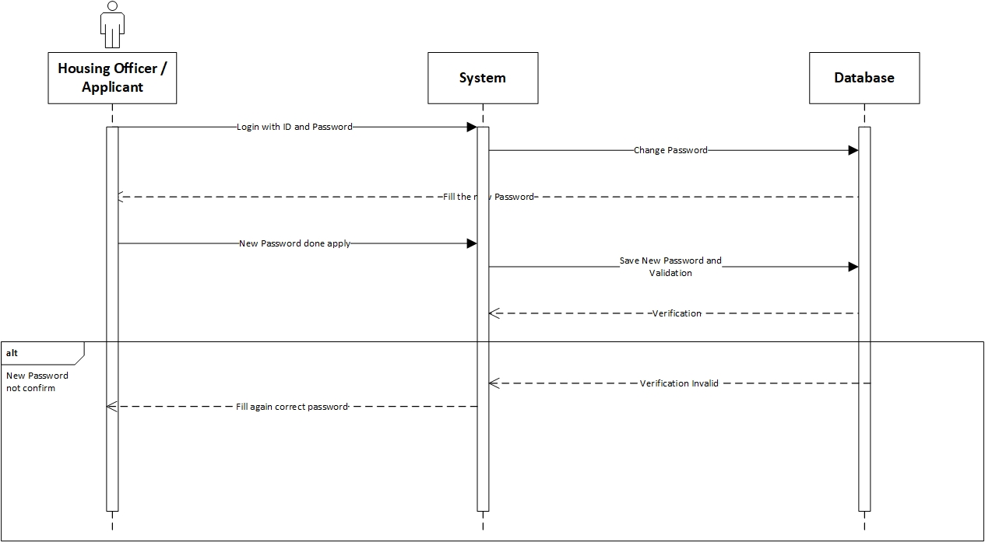

**Prepared by: Luh Wulandari Maharani**

|  |  |
| --- | --- |
| **Cross References** | **Change Password** |
| Operation | Enter current password |
| Responsible | To change the password |
| Pre-conditions | The new password must be available |
| Post-conditions | Successfully changed password |
| **Cross References** | **Change Password** |
| Operation | Enter current password |
| Responsible | To change the password |
| Pre-conditions | The user must be enter the new password again to confirm |
| Post-conditions | Fill again the form with the new password |

1. **Log Out**

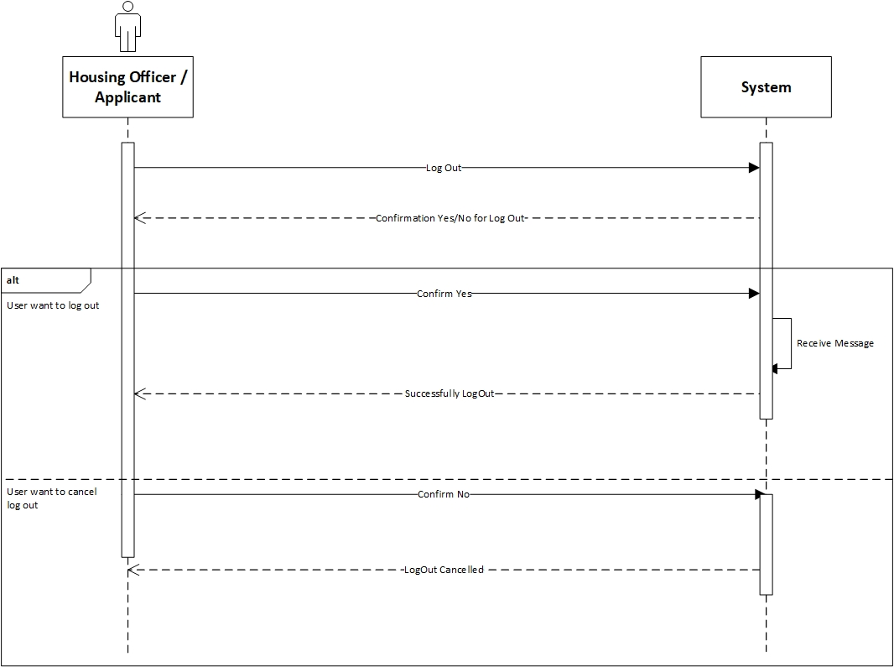

**Prepared by: Luh Wulandari Maharani**

|  |  |
| --- | --- |
| **Cross References** | **Log Out** |
| Operation | User want to log out |
| Responsible | To log out from the system |
| Pre-conditions | The user accepts that they want to log out |
| Post-conditions | Successfully log out |
| **Cross References** | **Log Out** |
| Operation | Cancel to log out |
| Responsible | To cancel log out from the system |
| Pre-conditions | The user cancel log out by click the “No” option |
| Post-conditions | Log out cancelled |

1. **View Applications**

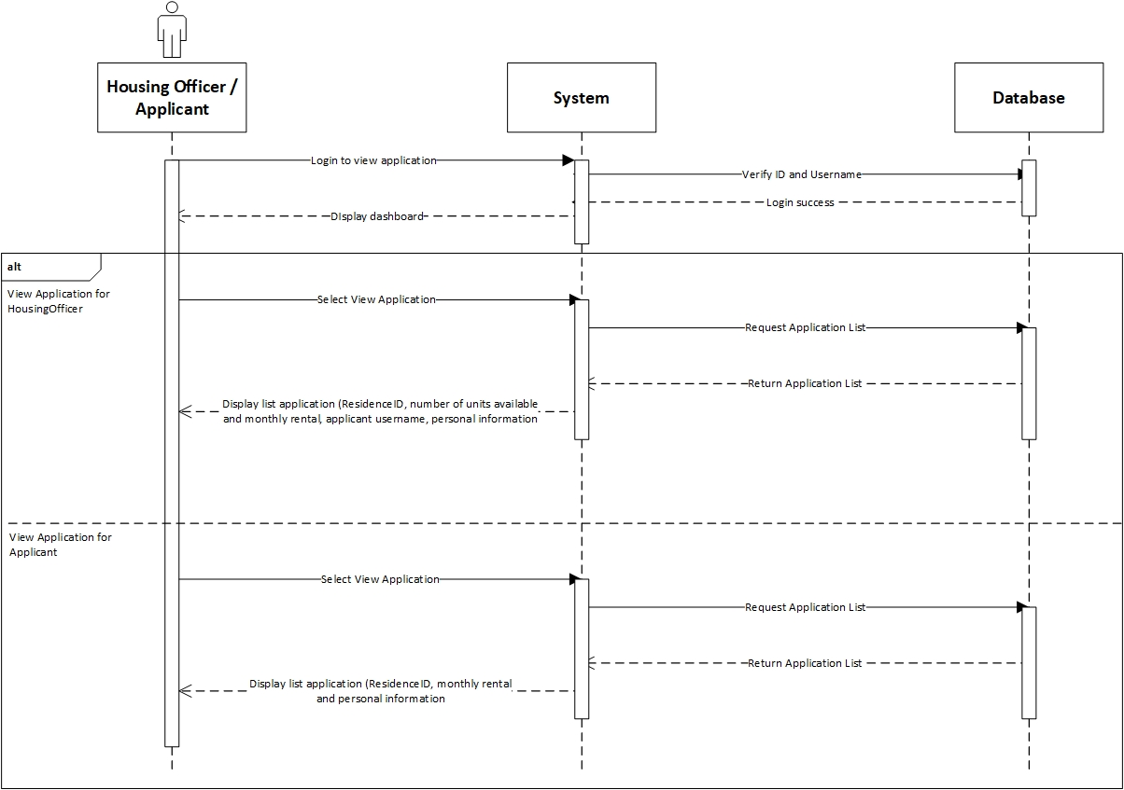

**Prepared by: Luh Wulandari Maharani**

|  |  |
| --- | --- |
| **Cross References** | **View Applications** |
| Operation | Login with username and password |
| Responsible | To get access to view the applications |
| Pre-conditions | * Username must be available * Password must be available |
| Post-conditions | * Username is matched * Password must be match based on user’s password input * Display dashboard |
| **Cross References** | **View Applications** |
| Operation | View Application in Housing Officer |
| Responsible | To view a list for the Residence that Housing Officer is responsible |
| Pre-conditions | The application object must be available |
| Post-conditions | The list of application with status for the Residence that the Housing Officer is responsible, showing the residence ID, number of units available, monthly rental, application username and personal information |

|  |  |
| --- | --- |
| **Cross References** | **View Applications** |
| Operation | View Application in Applicant |
| Responsible | To view a list of application that have been made for applicant |
| Pre-conditions | The application object must be available |
| Post-conditions | The list of application that have been made by the applicant, showing the residence ID, monthly rental and personal information |

1. **View Residences**

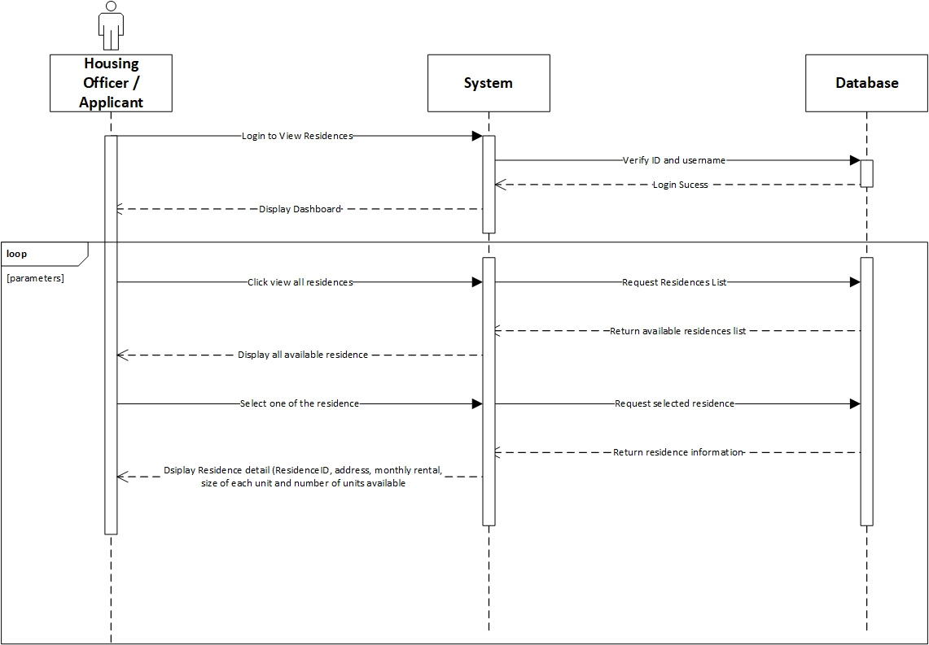

**Prepared by: Luh Wulandari Maharani**

|  |  |
| --- | --- |
| **Cross References** | **View Residences** |
| Operation | Login with ID and username |
| Responsible | To access the main page |
| Pre-conditions | * Username must be available * Password must be available |
| Post-conditions | * Username is matched * Password must be match based on user’s password input * Display dashboard |

|  |  |
| --- | --- |
| **Cross References** | **View Residences** |
| Operation | Click view all residences |
| Responsible | To get all list of the residences |
| Pre-conditions | The residence object must be available |
| Post-conditions | Success to display all residences of all residences |
| **Cross References** | **View Residences** |
| Operation | Select the residence to view |
| Responsible | To get information about selected residences |
| Pre-conditions | The residence ID must be available |
| Post-conditions | Success to display detail information about the selected residences |

1. **Set Up New Residences**

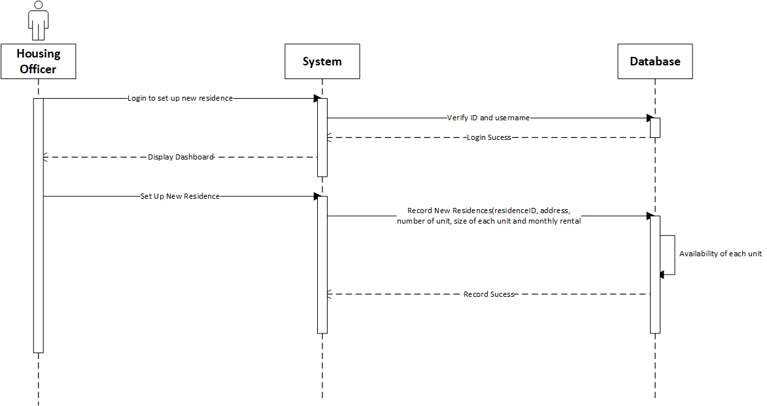

**Prepared by: Luh Wulandari Maharani**

|  |  |
| --- | --- |
| **Cross References** | **Set Up New Residences** |
| Operation | Login with ID and username |
| Responsible | To access the main page |
| Pre-conditions | * Username must be available * Password must be available |
| Post-conditions | * Username is matched * Password must be match based on user’s password input * Display dashboard |

|  |  |
| --- | --- |
| **Cross References** | **Set Up New Residences** |
| Operation | Set up new residences |
| Responsible | To set up the new residences by input the residenceID, address, number of units available, size of each unit and monthly rental |
| Pre-conditions | Object residenceID, address, number of units available, size of each unit and monthly rental must be available |
| Post-conditions | New residences was successfully added to the system |

1. **Allocate Housing**

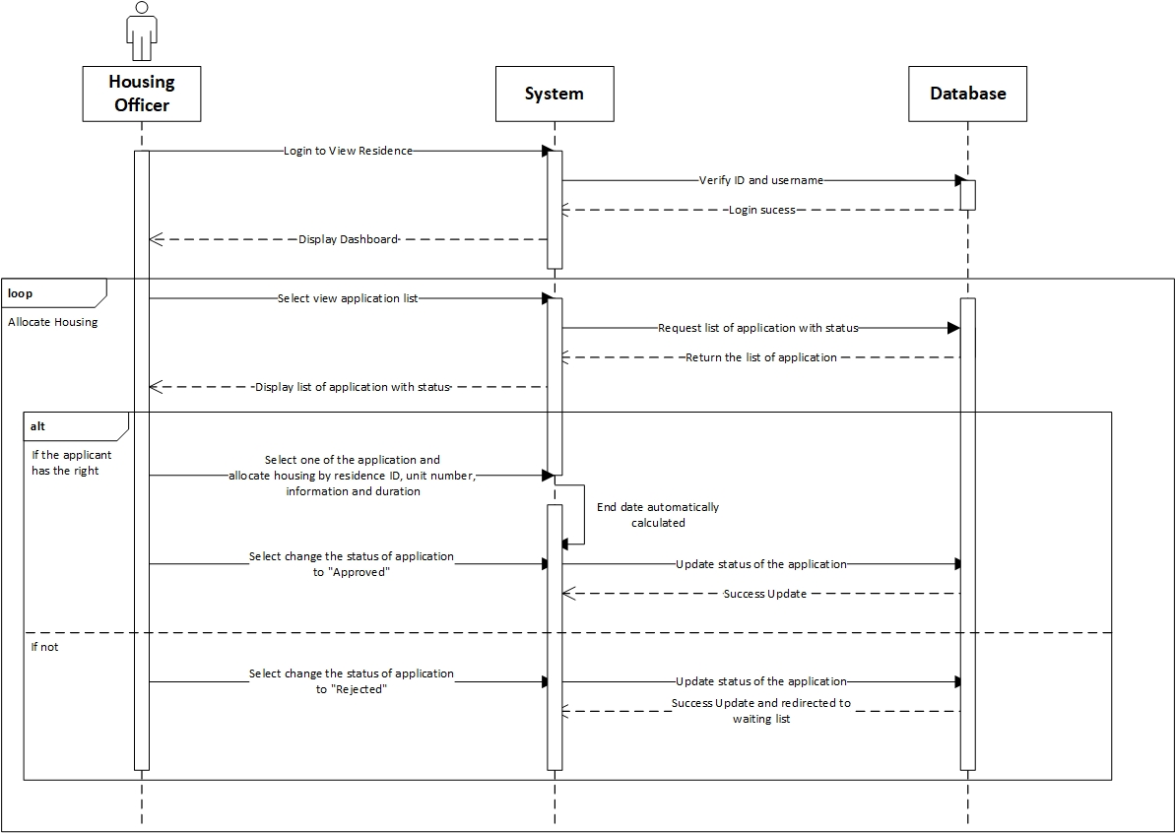

**Prepared by: Luh Wulandari Maharani**

|  |  |
| --- | --- |
| **Cross References** | **Allocate Housing** |
| Operation | Login with ID and username |
| Responsible | To access the main page |
| Pre-conditions | * Username must be available * Password must be available |
| Post-conditions | * Username is matched * Password must be match based on user’s password input * Display dashboard |

|  |  |
| --- | --- |
| **Cross References** | **Allocate Housing** |
| Operation | Select view application list |
| Responsible | To get the list of all application |
| Pre-conditions | The application object must be available |
| Post-conditions | Success displayed list of all application with status |
| **Cross References** | **Allocate Housing** |
| Operation | Select one of the application and allocate the housing |
| Responsible | To allocate the housing for an application |
| Pre-conditions | Object residenceID, unit number, from date and duration must be available |
| Post-conditions | Success create allocation object based on data input |
| **Cross References** | **Allocate Housing** |
| Operation | Select to changed status of to be “Approved” |
| Responsible | To change the status to “Approved” |
| Pre-conditions | Application object must be available |
| Post-conditions | Success changed the application status |
| **Cross References** | **Allocate Housing** |
| Operation | Select to changed status of to be “Rejected” |
| Responsible | To change the status to “Rejected” |
| Pre-conditions | Application object must be available |
| Post-conditions | Success changed the application status and redirected to waiting list |

1. **Sign Up Applicant**

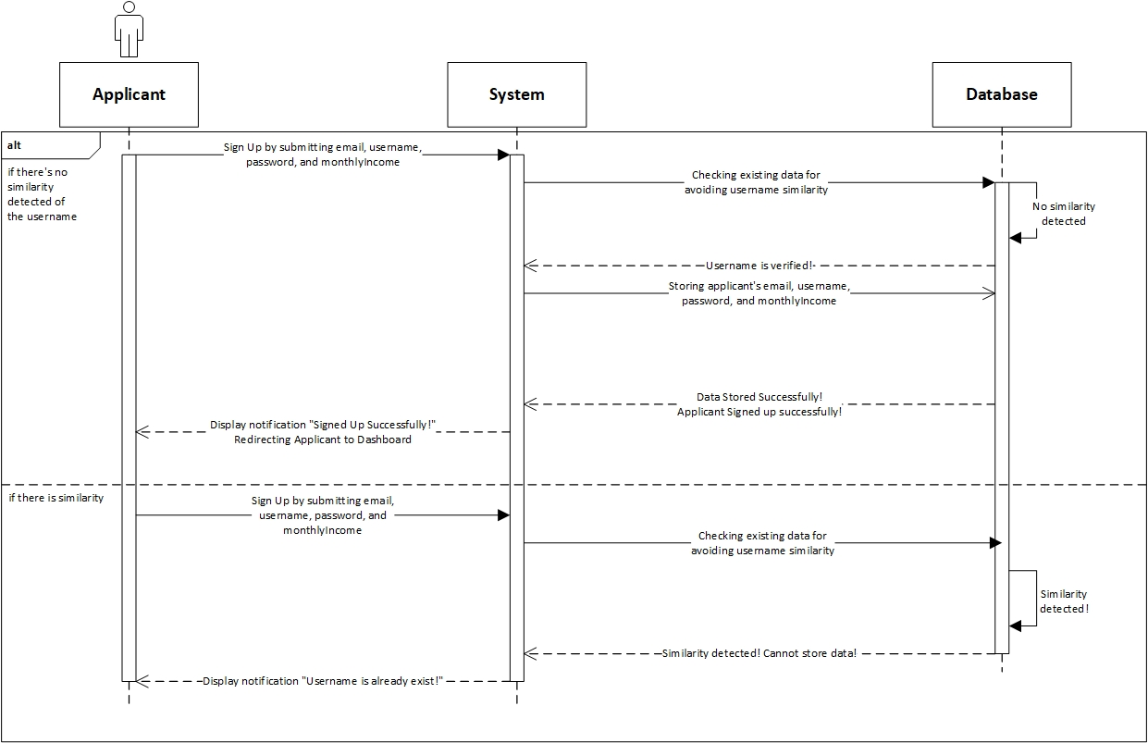

**Prepared by: Rivaldo Bagus Soepardhy**

|  |  |
| --- | --- |
| **Cross References** | **Sign up Applicant** |
| Operation | Sign up with email, username, password, and monthlyIncome |
| Responsible | To be registered in system and able to access the main page |
| Pre-conditions | * Email must be available * Username must be available * Password must be available * MonthlyIncome must be available |
| Post-conditions | * Username is verified (no similarity detected) * Registered in System * Display dashboard |
| **Cross References** | **Sign up Applicant** |
| Operation | Sign up with email, username, password, and monthlyIncome |
| Responsible | To be registered in system and able to access the main page |
| Pre-conditions | * Email must be available * Username must be available * Password must be available * MonthlyIncome must be available |
| Post-conditions | * Username is not verified (already existed in system) * Applicant must re-enter new username. |

1. **Edit Residence**

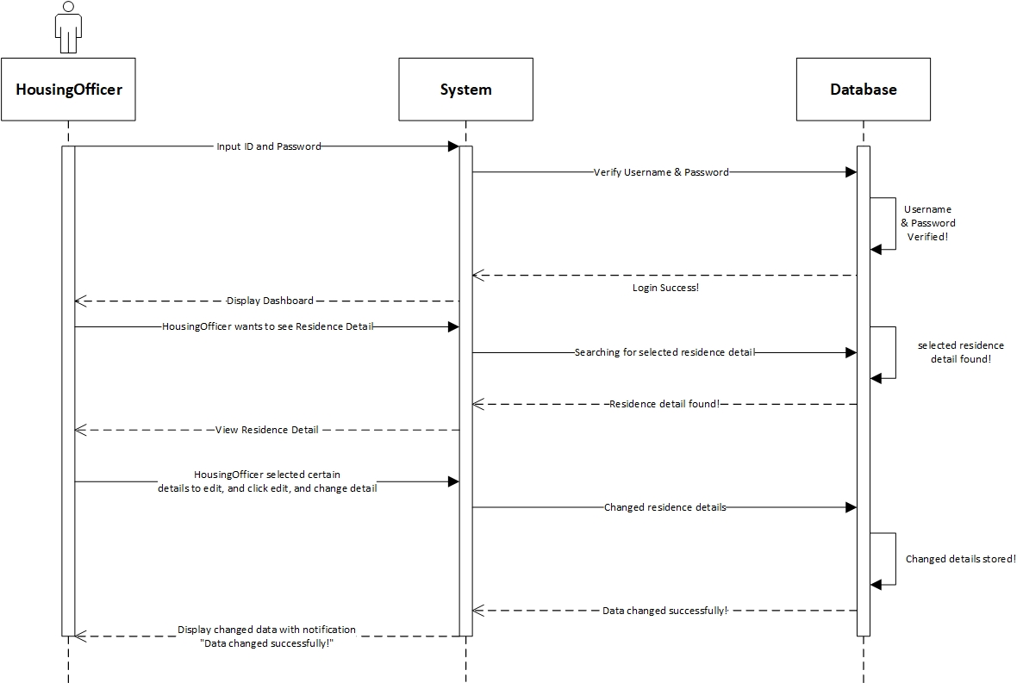

**Prepared by: Rivaldo Bagus Soepardhy**

|  |  |
| --- | --- |
| **Cross References** | **Edit Residence Detail** |
| Operation | Login with username and password |
| Responsible | To get access to view the applications |
| Pre-conditions | * Username must be available * Password must be available |
| Post-conditions | * Username is matched * Password must be match based on user’s password input * Display dashboard |
| **Cross References** | **Edit Residence Detail** |
| Operation | Edit residenceID, address, numUnits, sizePerUnit, monthlyRental |
| Responsible | To change certain Residence Detail |
| Pre-conditions | We will need **one of** or **all of** the details below:   * Email must be available * Username must be available * Password must be available * MonthlyIncome must be available |
| Post-conditions | Residence Detail changed successfully |

1. **Submit Application**

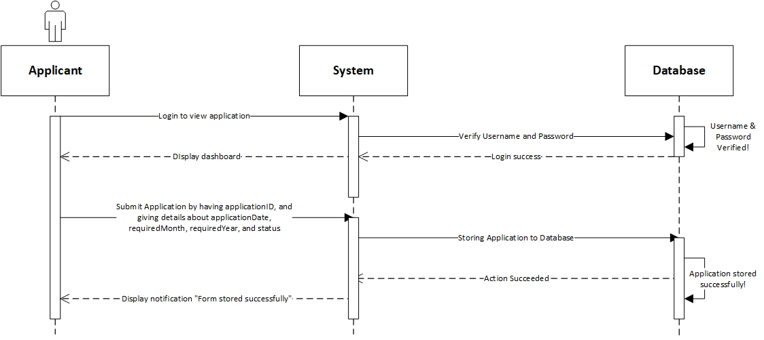

**Prepared by: Rivaldo Bagus Soepardhy**

|  |  |
| --- | --- |
| **Cross References** | **Submit Application** |
| Operation | Login with username and password |
| Responsible | To get access to view the applications |
| Pre-conditions | * Username must be available * Password must be available |
| Post-conditions | * Username is matched * Password must be match based on user’s password input * Display dashboard |
| **Cross References** | **Submit Application** |
| Operation | View Residence & Select Residence |
| Responsible | To submit applicant’s application to the database. |
| Pre-conditions | * Applicant is already logged in to the system * Applicant has already determine the desired residence |
| Post-conditions | User will view the list of the residence, and then select the desired residence. |
| **Cross References** | **Submit Application** |
| Operation | Submit applicationID, applicationDate, requiredMonth, requiredYear, and status |
| Responsible | To submit applicant’s application to the database |
| Pre-conditions | Applicant has already selected the residence. We will need **all of** the details below:   * applicationID will be given by system automatically * applicationDate must be available * requiredMonth must be available * requiredYear must be available * status will be given by system automatically |
| Post-conditions | Application will be stored successfully, and will be on waiting list for the approval & arrangement by HousingOfficer. |

1. **Delete Applicant**

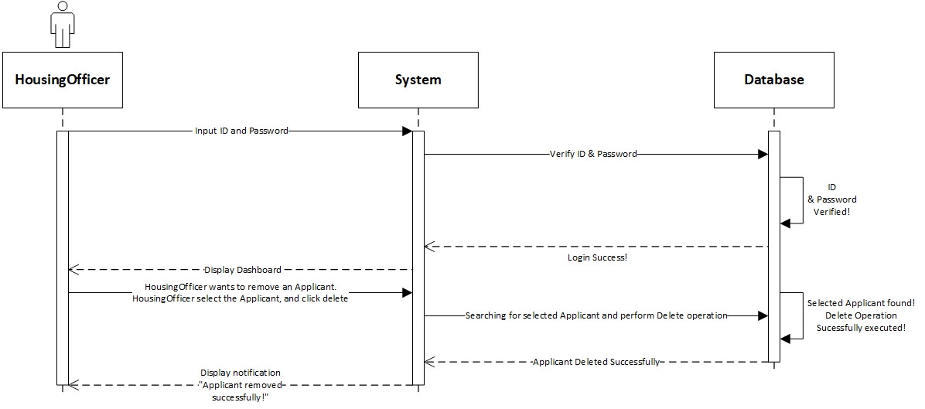

**Prepared by: Rivaldo Bagus Soepardhy**

|  |  |
| --- | --- |
| **Cross References** | **Delete Applicant** |
| Operation | Login with ID and username |
| Responsible | To access dashboard, and delete applicant |
| Pre-conditions | * Username must be available * Password must be available |
| Post-conditions | * Username is matched * Password must be match based on user’s password input * Display dashboard |
| **Cross References** | **Delete Applicant** |
| Operation | Delete Applicant |
| Responsible | To remove an applicant |
| Pre-conditions | The applicant object must be available, and the applicant is no longer in place (checkout) |
| Post-conditions | Applicant object will be removed successfully |

1. **Delete Applications**

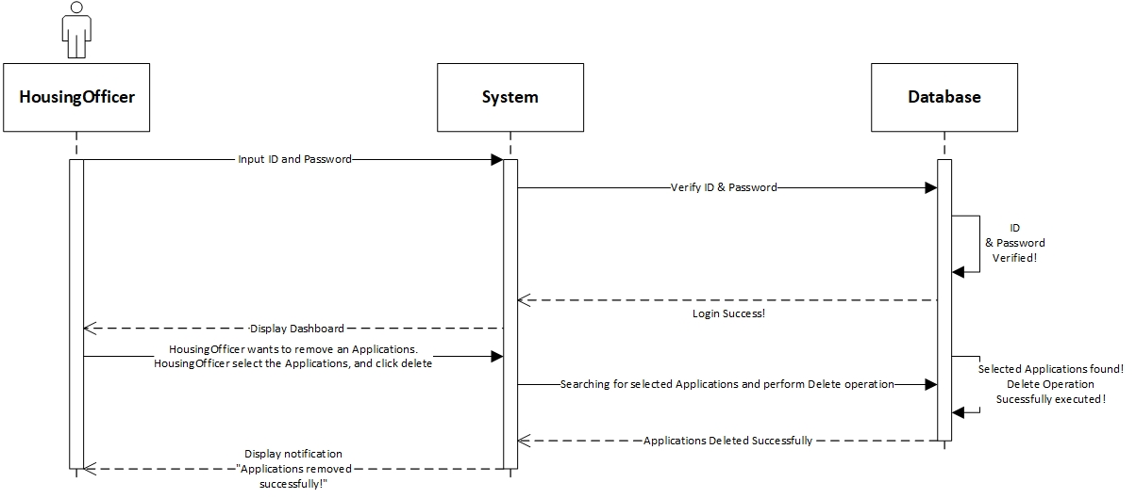

**Prepared by: Luh Wulandari Maharani**

|  |  |
| --- | --- |
| **Cross References** | **Delete Applications** |
| Operation | Login with ID and username |
| Responsible | To access dashboard, and delete applicant |
| Pre-conditions | * Username must be available * Password must be available |
| Post-conditions | * Username is matched * Password must be match based on user’s password input * Display dashboard |
| **Cross References** | **Delete Applications** |
| Operation | Delete Applications |
| Responsible | To remove an applications |
| Pre-conditions | The applications object must be available, and the applications is no longer in place (checkout) |
| Post-conditions | Applications object will be removed successfully |

Database Design

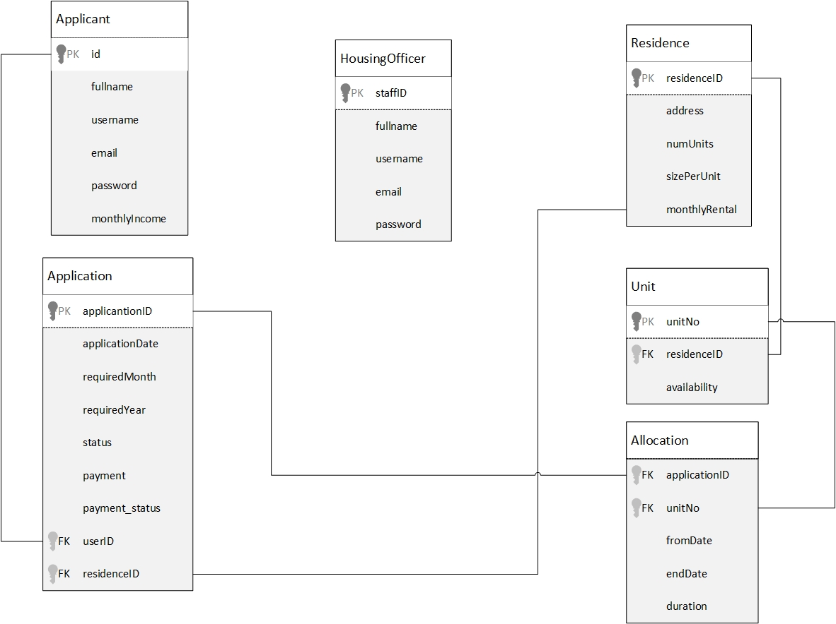

Iteration 1

Use Case

|  |  |  |
| --- | --- | --- |
| Use Case | Developed By | Testing |
| Login | Wulan | Iteration 1 |
| SignUp (For Applicant) | Wulan | Iteration 1 |
| Change Password | Wulan | Iteration 1 |
| Log Out | Wulan | Iteration 1 |
| View Application (HousingOfficer) | Wulan | Iteration 1 |
| Delete Application (HousingOfficer) | Wulan |  |
| Allocate Housing(HousingOfficer) | Wulan |  |
| Set Up New Residence(HousingOfficer) | Wulan | Iteration 1 |
| View Residence(HousingOfficer) | Wulan | Iteration 1 |
| Edit Residence(HousingOfficer) | Wulan |  |
| Delete Applicant(HousingOfficer) | Wulan |  |
| Submit Application(Applicant) | Aldo | Iteration 1 |
| View Applications(Applicant) | Aldo | Iteration 1 |
| View Residences(Applicant) | Aldo | Iteration 1 |

Test Objectives

The main reason of the testing of this system is very obvious and inevitable, to find mistakes or errors inside the system. Although there is no such a “perfect system”, it does not mean that we keep making systems without consideration and thorough testing. With this testing and a high frequency of testing, it will build confidence of the software quality, thus making us sure, the software will be very robust. Testing is not only about finding errors or mistake, but also to analyze the system and countering any possibility of errors that can possibly happen in the future.

For DBKL MicroHousing information system, our first objective is to make sure login validation works and password data is successfully encrypted with encryption provided by the framework we use to work. Then we test the application (web pages) across different web browser to ensure it is working properly. Next, we test the system according to the role:

* As HousingOfficer, he/she should be able to do basic CRUD (Create, Read, Update, Delete) operation in the system on certain object, such as residence, allocation, etc. HousingOfficer will be able to do some deciding action regarding application, whether to apply or reject it.
* As Applicant, he/she should be able view data only related to his role and application, such as Application Status, Payment, Residence, etc.

We also have to test all the links, buttons, pages, are working properly and directing to the right pages.

Test Plan

For the information system, we will be testing functions that will be performed by HousingOfficer and Applicant. We want to make sure that system boundaries are working. For example, Applicant cannot edit or delete data. Login system will also be tested, so that HousingOfficer and Applicant will be redirected to their own dashboard. During the testing process, we will test a function with several times of repeat to verify that the function has worked perfectly.

Unit Testing

LAGI DIBUAT WULAN

Integration Testing

n this integration testing, the testing will use the Selenium-WebDriver application. The system will run based on the functions that exist in each use case. The results of testing will be exported into JavaScript files.

1. Register Applicant

2. Login

3. Maintain Qualification

25

4. Record Programme

NANTI TESTNYA PAKAI SELENIUM

We use Selenium-Web Driver application. The system will run based on the functions existed in each use case. The result of the testing will be exported in a Python .py file.

1. Login Applicant

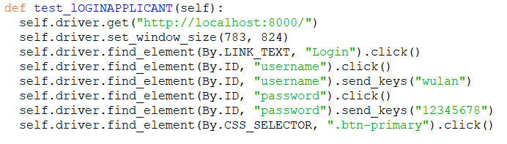

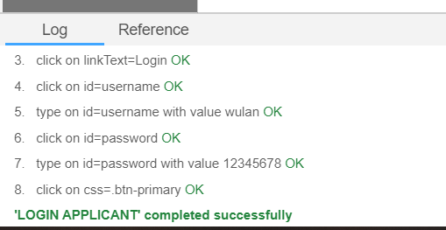

1. Register Applicant

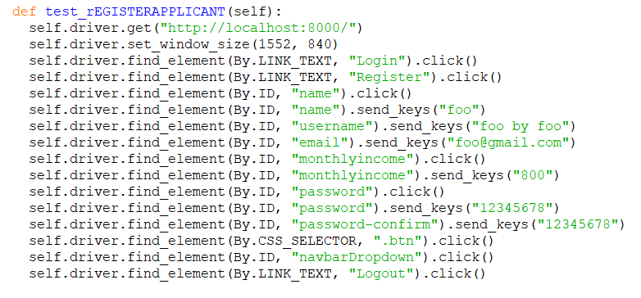

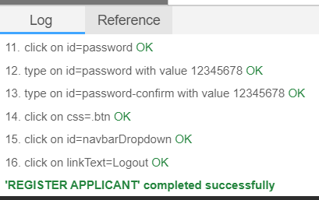

1. Submit Application – Applicant

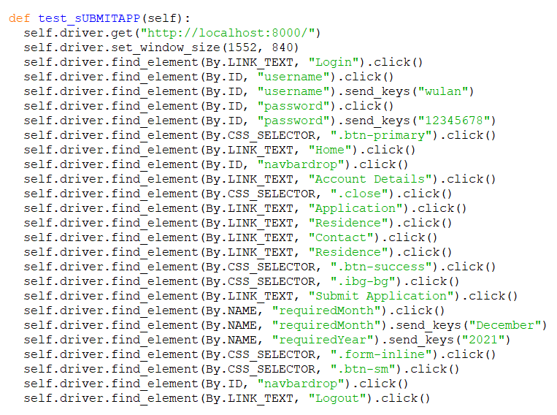

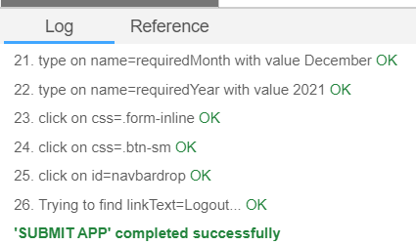

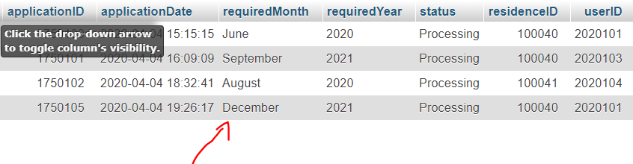

1. Login & Logout Housing Officer

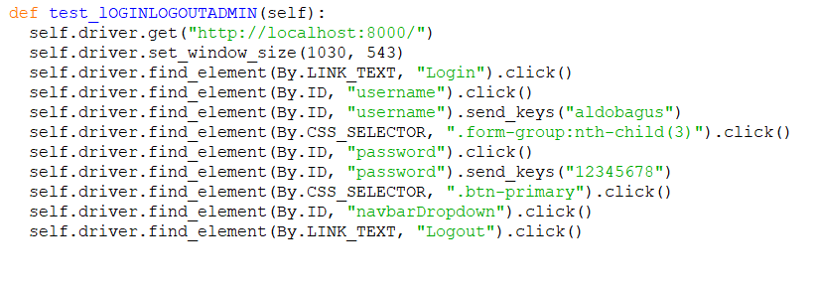

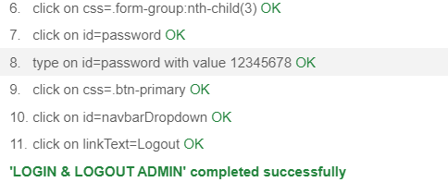

1. Set Up New Residence – HousingOfficer

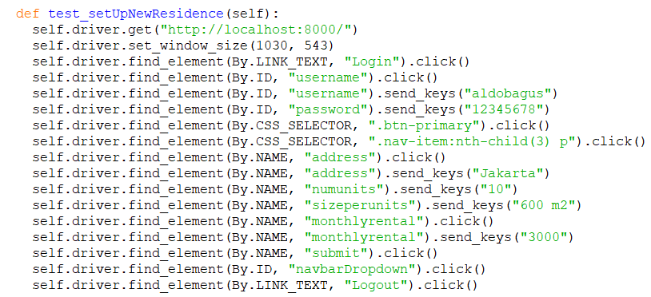

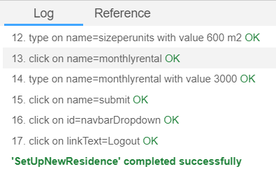

1. Edit Residence – HousingOfficer

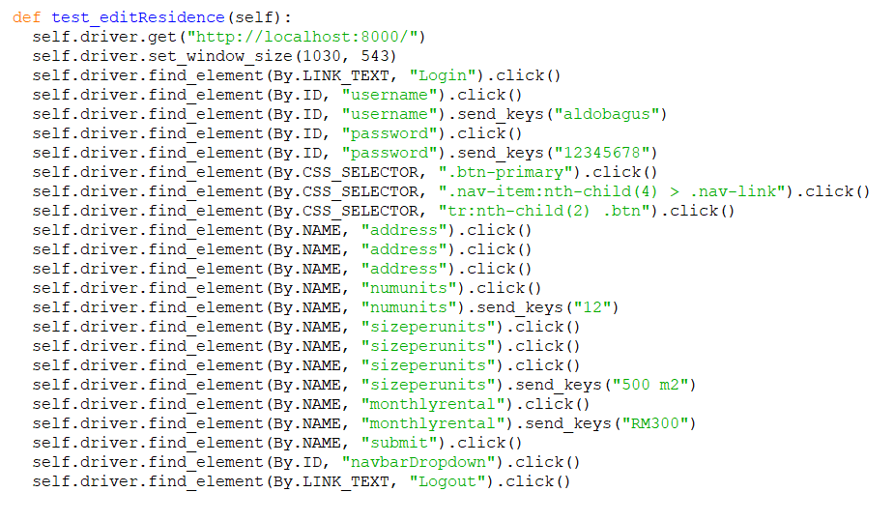

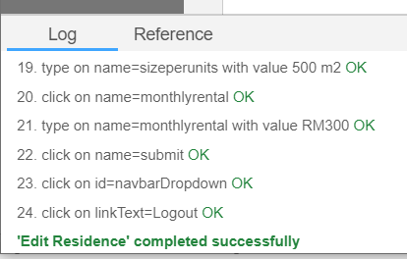

System Testing

1. Functional Requirements

We will test the system according to the functional requirements.

GAMBARRR

GAMBARRR

1. Non-functional Requirements

We will test the system according to the non-functional requirements that have been determined previously.

a. Usability

The system already have a simple interface design and easy to use also easy to understand. 28

b. Accuracy and Precision

The data entered by the user has been appropriate, accurate, and precise and there are no errors. And also, the data is in accordance with the data contained in the database.

Dsadsa

Test Analysis Report

After conducting all of the required tests, we can say the system is working normally.From unit, integration and system testing, we can say that the system and codes are working fine and has passed the testing process. The scope of our testing is to make sure every functions of the system can work perfectly according what the tasks they are assigned. Overall, we have found bugs and errors and have corrected it.

Updated Gantt Chart, Trello Board, GitHub

